THE BLOODHOUND CLUB  CHAMPIONSHIP WORKING TRIALS  At: Llanmaes (Llantwit Major) Vale of Glamorgan  On: Sunday 17th – Wednesday 20th^{th} October 2021  To be held under KC Rules & Regulations I & I(D) |  |  |  | 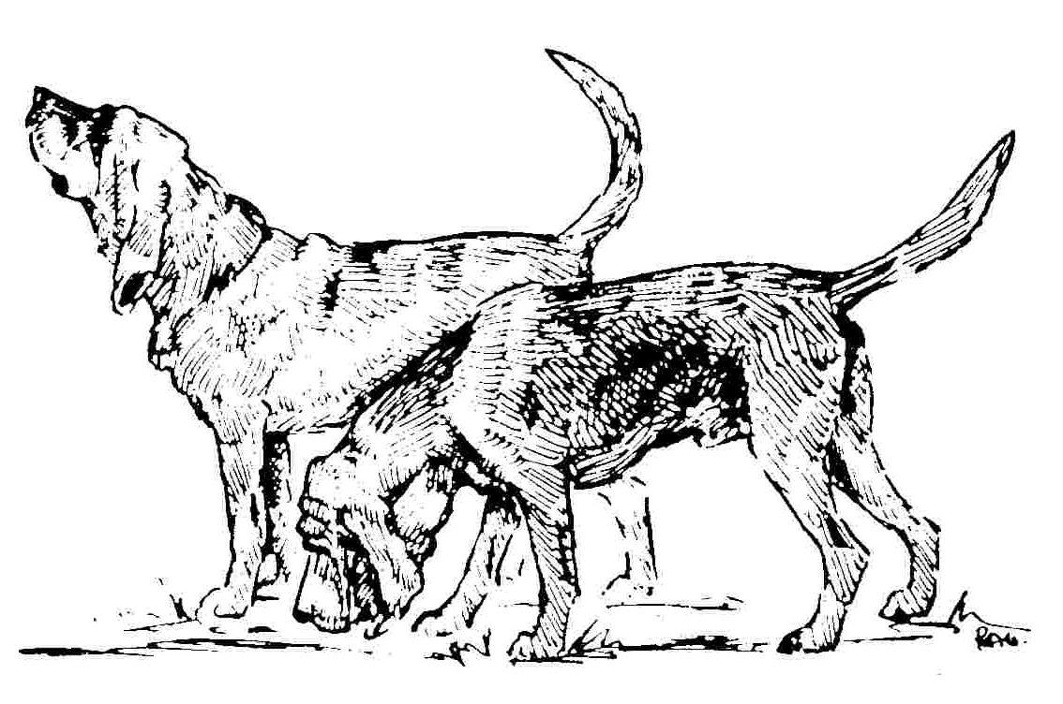 |  | Entries close:  To be received by  Noon Friday 8th Oct. 2021  Members: £20.00 Non Members: £25.00  On no account will entries  be accepted without fees. | Stake Entered
 |  |  |  |  |  |  | Hounds which have won a Novice, Junior or Intermediate Stake or have been placed 2nd in Novice or Junior Stake must be entered in the Stake above
INSTRUCTIONS: This form must be used by one person only (or partnership). Writing MUST BE IN INK OR INDELIBLE PENCIL. Use one form only for each hound. The name of the hound and all the details as recorded with the Kennel Club must be given on this entry form. If an error is made the hound may be disqualified by the Committee of the Kennel Club. All hounds must be REGISTERED at the Kennel Club in the name of the competitor. If the registration or transfer of ownership has not been confirmed it must be applied for before the closing date of entries. In case of dispute proof of postage of such applications may be required by the Kennel Club. If a hound is in the process of Registration or Transfer at the time entry is made, add the letters NAF or TAF as appropriate after its name. Hounds under 12 months of age on the day of the Trials cannot be entered for competition. On no account will entries be accepted without fees. Please use BLOCK CAPITALS throughout when completing this entry form.
In submitting this entry, all competitors agree that they have read, understood and abide by the risk assessment on the reverse of this entry form. This absolves the Club from liability in incidents, such as damage caused to a vehicle when forcible entry has been used to protect a dog deemed to be vulnerable and at risk, in high temperature, even on days considered as slightly warm.
PLEASE CHECK ALL DETAILS BEFORE POSTING. KC Registration No. or Authority to Compete No. for dogs registered outside the UK must be stated or the entry will be returned
REGISTERED NAME OF HOUND | BREED | SEX  D or B | DATE of BIRTH | BREEDER | SIRE |  | DAM
*KC Reg No. or *ATC No. | BLOOD HOUND
 |  |  |  |  | * MARK OPTIONS APPLICABLE
Qualifications for entry  Working Permit No.*ABB/BC……….. *Full / *Restricted  Date of Latest Stock Test Passed…………………….. |  |  |  | Highest Award at Championship Working Trials: *1st 2nd  *NOVICE JUNIOR INTERMEDIATE SENIOR  *ABB / B.C *SPRING / AUTUMN YEAR………….
DECLARATION  I/We agree to submit to and be bound by the Kennel Club Rules & Regulations in their present form or as they may be amended from time to time in relation to all canine matters with which the Kennel Club is concerned and that this entry is made upon the basis that all current single or joint registered owners of this hound have authorised/consented to this entry. I/We also undertake to abide by the Regulations of this Trial and not to bring to the Trial any hound which has contracted or been knowingly exposed to any infectious or contagious disease during the 21 days prior to the Trial, or which is suffering from a visible condition.  I/We further declare that I believe to the best of my knowledge that the hounds are not liable to disqualification under Kennel Club Regulations.  ALL registered owners must sign here unless the signatory holds written authority and consent from other joint registered owners to sign on their behalf; evidence of such authority may be required. NOTE: Hounds entered in breach of Kennel Club Regulations are liable to disqualification whether or not the owner was aware of the breach.  Note: Children under the age of 11 are the responsibility of a parent or guardian and must be supervised at all times including when competing.  Usual signature(s) of owner(s)………………………………………Date……….. |  |  |  | In the case of joint registered ownership the name of every owner must be given If you do not wish your details to appear in the Catalogue, tick the box  Name(s)……………………………………………………………………………………….. Address………………………………………………………………………………………...  …………………………………………………………………………………………………..  ………………………………………………………………………………………………….. Phone No: …………………Mobile No:……………………E-mail…………………………  Handler:…………………………………………………DoB (if under 18 years)………… Has the handler handled any bloodhound when winning a Stake at Trials? *Yes/ *No Entries and fees which must be prepaid (cheques made payable to the Bloodhound Club) to:  Mr. R Manley, 3 Broadbridge, Beercrocombe, Somerset TA3 6AQ  Tel: 07703 417737 email: rob.manley72@gmail.com

The Bloodhound Club Working Trials Risk Assessment
WARNING: DOGS IN CARS ON HOT DAYS
Your dog is vulnerable and AT RISK if left in a vehicle in high temperatures
and even on days considered as slightly warm. Please take care of your dog.
If your dog is found to be at risk, forcible entry to your vehicle may be
necessary without liability for any damage caused.
Right to Refuse Entries:
Competitors are reminded that Trials Societies have the right under Kennel Club
Regulations to refuse any entry.
Anyone whose hound is entered at a Kennel Club licensed event should take all
reasonable steps to ensure the needs of their hound(s) are met, and should not put a
hound’s health and welfare at risk by any action, default, omission or otherwise.
Breach of Kennel Club Regulations in this respect may be referred to the Board for
disciplinary action under Kennel Club Rules and Regulations.
Travelling to, at and leaving KC licensed events
• When travelling to Trials please take a moment to consider whether the route to
the Trials is on a busy holiday route, and leave earlier to avoid increased
time in traffic jams.
• Ensure your hound is not sitting in full sunlight. There should be plenty of free
flowing air around the hound.
• Keep the hound in the shade – take your own shade, for example a large
umbrella, and always have plenty of water available to drink, so your
hound stays well hydrated.
• Remember, if you feel hot your hound is very likely to feel much hotter
and dehydrated, and this could lead to dire results.
Please look after your hound’s' welfare.
Risk with open doors or windows
Traffic, people and hounds are at risk if dogs can escape
Vehicle windows and doors, where open, should be grilled.
Weather conditions
The judge or stake manager can intervene, in the event of
Risk to health due to adverse / bad weather.
In the Catalogue/Programme, participants are advised of an appropriate
Veterinary Surgery and A&E Hospital, as well as those carrying
a first aid kit in their vehicle at the trials.
The Meet
Risk of traffic congestion.
The meet should be well signposted to help avoid traffic congestion or risk of injury from traffic.
The meet should be held off road in a position where cars can be parked
allowing room for competitors and hounds to move safely.
Risk of injury caused by hounds.
Children and animals should be under control at all times.
Competition
The handler will be encouraged to consider the hound’s safety at all times whilst
competing, to avoid injuries
Risk on Roads
Besides the provision that all equines and pets should be under control at all times,
owners should avoid danger from and to traffic.
Competitors and all participants should observe guidance from Road Marshals and
Stake Managers for suitable parking for the road conditions.
Hound and handler
• When competing, the handler should take precautions when approaching
any road.
• Whenever a line has been walked across a road, then a flag should be
placed on the other side to avoid delay on the road.
• If there is no flag, then the handler should be aware, and keep away
from roads, unless indicated by the road marshal or judge.
Judge, assistants and line walker
• The handler should always be asked by the judge or assistants before they
consider handling a hound.
• The handler should assist the hound through obstacles, not the judge.
Road accidents
Hounds should be under effective control at all times and are hunted
unleashed entirely at the owner/handler’s risk.
Owners should ensure that their insurance cover is adequate for these risks
Risk from or to livestock
• The Stake Manager will avoid land with stock where landowners have informed
of any danger.
• The line walker should inform the Stake Manager, to warn the judge/assistants
of any concerns.
• The handler should inform judge if he has any concerns about the safety to the
hound or livestock, and consider retiring rather than taking any risks.
Risk of electric shock
Although we try to ensure electric fences are turned off, this cannot be guaranteed,
and competitors should satisfy themselves of this before proceeding.
Summing Up / Prize Giving
To reduce risk to hounds, competitors and general public, summing up should be in a
safe place. Hounds may be required to be removed if asked.
Where possible the summing up is held in a warm dry place.

